43.58: (See Problem (43.51)) 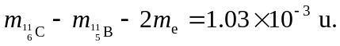 Decay is energetically
possible.

